|  |  |  |  |  |  |  |
| --- | --- | --- | --- | --- | --- | --- |
| **Sr No.** | **Name of Student** | **System ID** | **Group No** | **Title of Research Paper/Project** | **Abstract Submission Link** |  |
| 1 | Ujjwal Dwivedi | 2022463553 | **PBL_G1_1** | **Digital Diary**  **&**  **Sentiment**  **Analysis** | A diary application that, besides logging daily entries, can analyze the mood based on text and provide insights over time. |  |
| 2 | Rayhans Madhup | 2022006982 |  |
| 3 | Prince Kumar | 2022006679 |  |
| 4 | Meem Ibna Ashraf | 2023809271 |  |

**Digital Diary And Sentiment Analysis**

**Approved Project Title: Digital Diary And Sentiment Analysis**

**Modified Title: Emotion-Driven Habit Tracker**

**Proposed Patent Title: Emo-Habit Tracker**

**Idea Conception:** Emo-Habit Tracker is a revolutionary digital tool designed to empower individuals to manage their emotions and build healthier habits. By combining emotion recording and sentiment analysis, it identifies recurring emotional patterns, helping users gain profound self-awareness. The app then offers personalized habit-forming strategies, tailored to each user's unique emotional profile. Whether it's stress management, enhancing positivity, or improving overall emotional well-being, EmoHabit Tracker guides users on their journey to a more emotionally balanced and fulfilling life. With this innovation, self-improvement is now as simple as keeping a diary.

**Field of Invention:** The field of invention pertains to digital technologies and sentiment analysis. Specifically, it encompasses the use of digital diaries or journaling applications to collect and analyze user-generated text-based data for sentiment analysis and emotional well-being assessment.

**Background:** In today's digital age, people are increasingly using digital diaries or journaling applications to record their thoughts, feelings, and experiences. Simultaneously, sentiment analysis has become an essential component of many applications, providing insights into users' emotional states and mental well-being. However, there is a need for a system that combines digital diary-keeping with sentiment analysis to offer users a comprehensive understanding of their emotions and mental states.

**Objectives of the Invention:**

The primary objectives of the invention are as follows:

* To create a digital diary or journaling application that allows users to input and store text-based entries describing their daily experiences, thoughts, and emotions.
* To incorporate sentiment analysis algorithms that can assess the emotional tone and sentiment of the user's diary entries.
* To provide users with insights into their emotional well-being and mental states based on the sentiment analysis.
* To offer personalized recommendations, coping strategies, or support resources based on the sentiment analysis results to improve users' mental well-being.

**Statement of the Invention:** The invention is a system that combines digital diary-keeping with sentiment analysis to assess and improve the mental well-being of users by allowing them to record their thoughts and emotions in a digital diary and providing sentiment analysis-based insights and recommendations.

**Figure:**

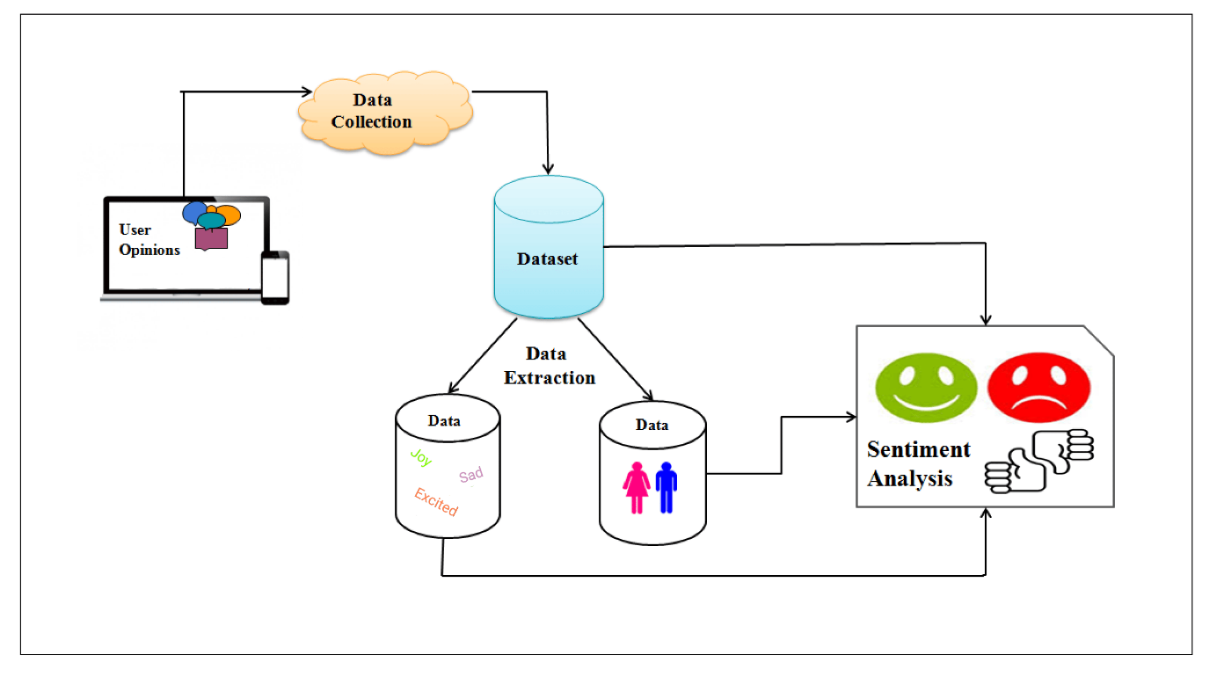

**Claims:**

* A digital diary and sentiment analysis system comprising a user interface for entering text-based diary entries and a sentiment analysis module for assessing the emotional tone of said entries.
* The system as claimed in claim 1, further comprising a recommendation engine for providing personalized recommendations to users based on the results of the sentiment analysis.
* A method for assessing and improving user mental well-being through the combination of digital diary-keeping and sentiment analysis, as described in claims 1 and 2.

**Abstract:** The invention relates to a digital diary and sentiment analysis system designed to assist users in understanding and improving their mental well-being. Users can input diary entries, and the system employs sentiment analysis to provide insights and recommendations based on the emotional content of the entries.

**Patent Application:** File a provisional or complete specification at the appropriate patent office, such as the Indian Patent Office (IPO). Consult with a patent attorney or agent for guidance and to ensure correct drafting and filing, especially if you intend to seek international protection under the Patent Cooperation Treaty (PCT).

**Important consideration:** When developing and implementing the Emo-Habit Tracker, there are several important considerations to keep in mind:

* **Privacy and Data Security:** Ensure robust data encryption and user privacy protection as emotional data can be sensitive. Users should have confidence that their emotional information is kept secure.
* **Ethical Use of Data:** Emotion data analysis should be conducted ethically, respecting user consent and privacy. Avoid any misuse or exploitation of personal emotional information.
* **Accuracy of Sentiment Analysis**: Invest in reliable sentiment analysis algorithms to provide users with accurate emotional insights. The system's success hinges on its ability to identify and interpret emotions correctly.
* **User-Friendly Interface**: Design a simple and intuitive user interface that encourages regular usage. Users should find it easy to record emotions and interact with habit-forming recommendations.
* **Customization:** Emo-Habit Tracker should adapt to individual needs. Allow users to personalize their emotional tracking and habit-forming strategies.
* **Behavioural Psychology Expertise:** Involve behaviouralpsychologists or experts in habit formation to ensure that the habit-building recommendations are grounded in sound psychological principles.
* **Continuous Improvement:** Plan for iterative updates and improvements based on user feedback and evolving emotional intelligence research.
* **Mental Health Support:** If the Emo-Habit Tracker identifies concerning emotional patterns, ensure that it provides guidance on seeking professional help or resources.
* **User Consent and Data Ownership:** Clearly define terms of data ownership and usage in the app's terms and conditions. Users should have a say in how their data is utilized.
* **Compatibility and Accessibility:** Ensure the app is accessible across various devices and platforms to reach a broader user base.